Lab Assignment #7
Space Satellite Launch Inertial Loading

EAE 133 - Finite Element Methods in Structures
Professor N. Sarigul-Klijn
TA: Noah Derita

Aurian Malhotra
920005606
Section A04, 11/13/2025

Introduction
This lab introduced the process of modeling and analyzing a three-dimensional structural system using finite element methods. The objective was to idealize a satellite assembly composed of thin plate-like components (Figure 1) and evaluate its structural response under inertial loading representative of launch conditions. Each major component was represented using shell elements with material and thickness properties (Tables 1 and 2) taken from the design specifications. The model was subjected to translational constraints at the platform corners and an inertial load representing a <2, 2, –10> g launch acceleration.

Figure 1: Idealized Satellite Model to be Analyzed
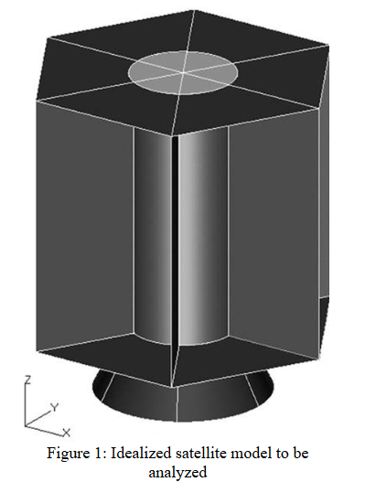

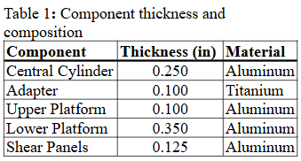

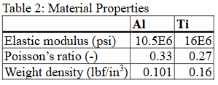

Figure 2: Relevant Satellite Dimensions (inches)
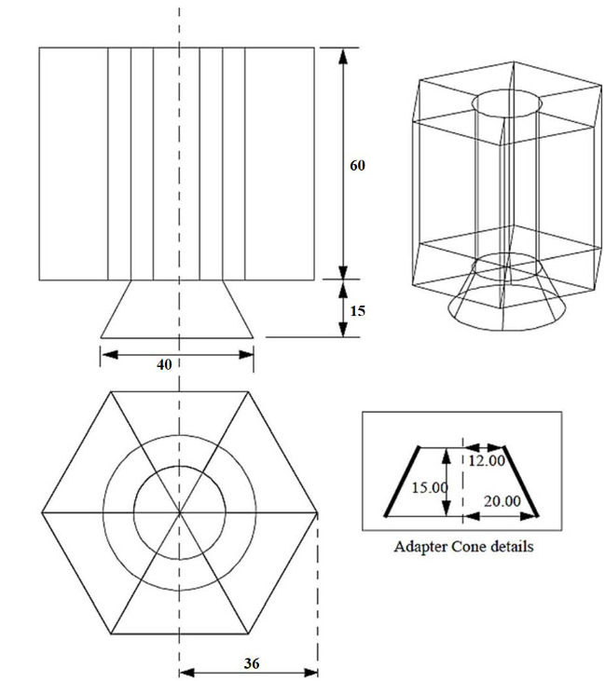

The analysis focused on generating the geometry, applying appropriate mesh controls, defining the correct coordinate system for inertial loads, and obtaining the deformed shape and stress distribution. In addition, the mass properties and center of gravity (CG) of the satellite were computed to verify correct material assignments and element thickness definitions. The results provide insight into load paths and stress concentrations that develop during launch, as well as how the satellite responds as a rigid body under these accelerations.

Procedure
The modeling process began with constructing the 3D geometry of the satellite using groups to separately manage the lower platform, upper platform, central cylinder, shear panels, and adapter. The lower platform was created first by generating circular sections using curve and revolve operations. This surface was then patterned in 60° increments to complete the full 360° geometry. The upper platform was generated by translating this surface upward by the specified 60-inch height, maintaining identical shape and symmetry.

The central cylinder and shear panels were created by extruding circular and radial edges upward between the two platforms. The adapter cone was modeled by creating an angled line below the lower platform and revolving it to form a six-panel conical section. After all components were constructed, a final “All Geometry” group was created to consolidate the full model.

Figure 3: 3D model of undeformed structure in Patran
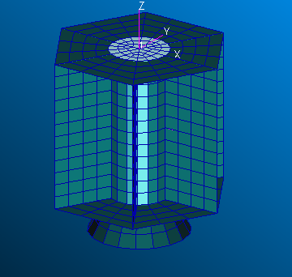

Figure 3 shows the completed undeformed satellite geometry with all major components visible. The structure consists of a cylindrical core, six shear panels, upper and lower platforms, and a tapered adapter section.

Each component was then meshed individually using controlled global edge lengths: 5 in for the adapter and shear panels, 5 in for the cylinder, and 6 in for the upper and lower platforms. Quad4 shell elements were used throughout to maintain consistency. After meshing, the model was equivalenced to remove duplicate nodes and ensure connectivity between components.

A launch coordinate system was created below the adapter cone using a three-point definition to establish the correct inertial frame. All nodes were reassigned to this new analysis coordinate system. Aluminum and titanium materials were defined based on the properties provided, and shell thicknesses were assigned to each component according to the design table.

Mass properties were calculated to verify proper material and thickness assignment. Finally, constraints were applied at the platform corner nodes, and inertial loads corresponding to 1 g in the x-, y-, and z-directions were defined and scaled to produce the <2, 2, –10> g launch vector. A linear static analysis was performed, and graphical outputs were generated for the undeformed model, the deformed model with stress contours, and deformation plots that illustrate displacement trends.

Results

Figure 4: Deformed Structure With Stress Distribution
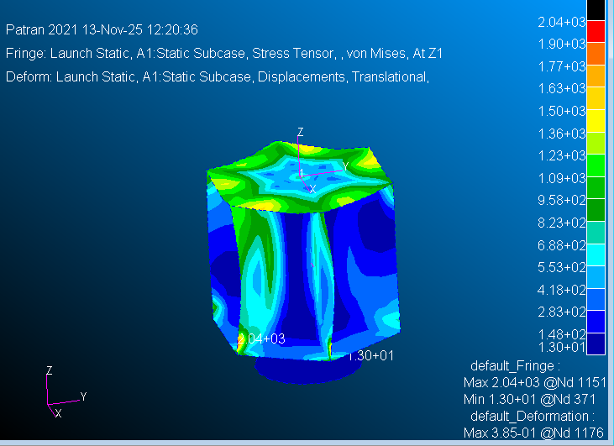

The deformed shape in Figure 4 with stress contours illustrates how the satellite responds to the combined <2, 2, –10> g inertial load. The largest stresses appear around the connections between the central cylinder, shear panels, and platform edges, which makes sense because these areas transfer the majority of the inertial loading.

Figure 5: Deformed Structure Translational Displacement-Focused
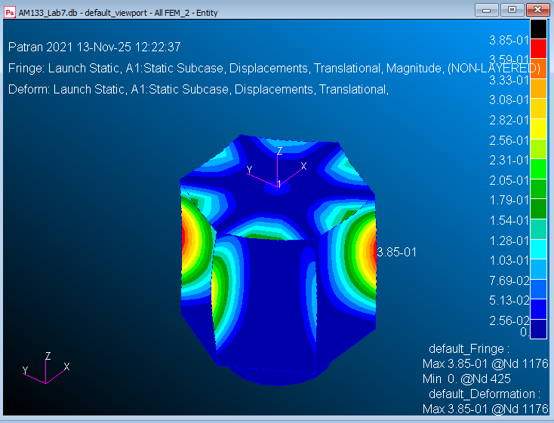

The displacement plot in Figure 5 shows the translational displacement magnitude. The maximum displacement occurs around the mid-height of the shear panels, between the upper and lower platforms, while the constrained corner nodes on the platforms show essentially zero displacement. This matches the expectation that the spanning panels bend the most under the applied <2, 2, –10> g inertial load.

Table 3: Nodal Displacement Extremes
 | Displacement (in) |  |  | Node
Minimum | [0.0, 0.0, 0.0, -2.051090E-04, 8.036935E-04, 4.120379E-04] |  |  | 425
Maximum | [3.329773E-01, 1.923092E-01, -9.597681E-04, -1.105240E-03, 1.924468E-03, 2.073388E-02] |  |  | 1176

Table 4: Stress Extremes
 | Stresses (psi) |  |  | Node
Minimum | [1.187994E+01, 6.769163E+00, 7.664378E-01] |  |  | 371
Maximum | [-4.752836E+02, -3.039760E+03, 6.371375E+01] |  |  | 1151

Table 5: Mass Properties and Center of Gravity
 | X | Y | Z
C.G. (in) | 8.772E-08 | -1.168E-07 | 2.995E+01
Principal Inertia (in⁴) | 1.922E+05 | 1.922E+05 | 1.097E+05
Radii of Gyration | 2.602E+01 | 2.602E+01 | 1.966E+01
Total Mass (lbm) | 2.839E+02 | N/A | N/A
Volume (in³) | 2.711E+03 | N/A | N/A

The displacement and stress tables (Tables 3 and 4) list the corresponding minima and maxima at nodes 425, 1176, 371, and 1151, confirming what is observed in the contour plots. The mass-properties/CG table shows that the center of gravity is nearly on the central axis in X and Y and located about 30 inches above the base, with a total mass of roughly 2.8 x 10² lbm, indicating that the model’s materials and thicknesses were defined consistently.

Discussion/Conclusion
The satellite model behaved as expected under the applied inertial launch loading. The stress distribution shows clear load paths from the upper platform through the shear panels and into the central cylinder, which acts as the primary structural backbone. High stresses occurred at geometric transitions, particularly where surfaces meet with sharp stiffness changes. These are reasonable locations for peak stresses and match the physical intuition of how the structure would respond under combined vertical and lateral accelerations.

Displacement results confirm that the structure experiences a combination of rigid-body motion and elastic deformation. The dominant downward displacement reflects the –10 g component of the load, while the smaller lateral deflections correspond to the 2 g accelerations in X and Y. The magnitudes of displacement are small relative to the overall dimensions of the satellite, indicating that the selected shell thicknesses and materials provide sufficient stiffness for launch conditions.
The mass properties output validates the modeling approach, with symmetric CG coordinates and principal inertias that match the geometry. This confirms that materials and thicknesses were properly assigned, the mesh was consistent, and all elements contributed correctly to the mass calculation.
The final section of this lab reinforces how important it is to build a clear geometric model and apply loads correctly in a finite element setting. Creating separate groups for each component, defining a consistent mesh, assigning shell properties, and working within the correct coordinate system were all essential for obtaining meaningful results. By stepping through each of these tasks, this lab demonstrated how complex three-dimensional structures can be analyzed using the same fundamental principles learned in earlier 2D labs. Overall, the workflow helped build confidence with 3D FEM tools and showed how different components interact under combined inertial loading.

